Promoting National Initiatives for
Technology-Mediated Social Participation
Jennifer Preece and Ben Shneiderman
University of Maryland, College Park, MD, USA
preece@umd.edu ben@cs.umd.edu

Technology-mediated social participation (TMSP) is generated when social networking tools (such as Facebook), blogs and microblogs (Twitter), user-generated content sites (YouTube, Flickr), discussion groups, problem reporting, recommendation systems, and other social media are applied to national priorities such as health, energy, education, disaster response, environmental protection, business innovation, cultural heritage, or community safety.
Fire, earthquake, storm, fraud, or crime reporting sites provide information to civic authorities, AmberAlert has more than 7 million users who help with information on child abductions, Peer-to-Patent provides valuable information for patent examiners, and the SERVE.GOV enables citizens to volunteer for national parks, museums and other institutions. These early attempts hint at the vast potential for technology-mediated social participation, but substantial research is needed to scale up, raise motivation, control malicious attacks, limit misguided rumors, and protect privacy (http://iparticipate.wikispaces.com).
As national initiatives are launched in several countries to dramatically increase research and education on social media, a coordinated approach will be helpful. Clearly stated research challenges should have three key elements: (1) close linkage to compelling national priorities (2) scientific foundation based on established theories and well-defined research questions (privacy, reciprocity, trust, motivation, recognition, etc.), and (3) computer science research challenges (security, privacy protection, scalability, visualization, end-user development, distributed data handling for massive user-generated content, network analysis of community evolution, cross network comparison, etc.).
Potential short-term interventions include:
- universities changing course content, adding courses, and offering new degree programs
- industry helping researchers by providing access to data and platforms for testing
- government agencies applying these strategies in pilot studies related to national priorities

National Science Foundation Workshops

Under support from the U.S. National Science Foundation, Jennifer Preece (Principal Investigator), Peter Pirolli (Co-PI), and Ben Shneiderman (Co-PI) organized workshops in Palo Alto, CA (December 10-11, 2009) and Arlington, VA (April 22-23, 2010). The focus was on Technology-Mediated Social Participation (www.tmsp.umd.edu) which was intended to encompass civic efforts that would benefit local, regional, national, and international communities. The 60+ participants included a range of faculty and graduate students from a variety of disciplines, plus representatives of key corporations, government agencies, and non-government organizations.

The breakout groups from the West Coast meeting produced three draft reports that were circulated among the attendees for comments. Two East Coast workshop attendees took on the responsibility to present each draft report to the entire workshop, and then lead discussions about refinements. In addition, three East Coast breakout groups generated three additional draft reports. The groups developed six chapters covering scientific foundations, infrastructure for research, design issues, health/wellness, open government, and educational reforms. The Special Issue (featured on cover) will appear in the November 2010 issue of IEEE Computer with an Introduction and six articles from workshop participants:

Introduction - Cyberinfrastructure for Social Action on National Priorities
Peter Pirolli, Jenny Preece, Ben Shneiderman
Scientific Foundations: A case for Technology Mediated Social Participation Theory
Robert Kraut, Mary Lou Maher, Judith Olson, Thomas W. Malone, Peter Pirolli,
John C. Thomas
Advancing the Design of Social Participation Systems
Ed H. Chi, Sean Munson, Gerhard Fischer, Sarah Vieweg, Cynthia Parr
Visions of What is Possible With Sharable Socio-technical Infrastructure.
Gary Olson, Gloria Mark, Elizabeth Churchill, Dana Rotman

Participating in Health
Bradford W. Hasse, Derek Hansen, Thomas Finholt, Wendy Kellogg, John C. Thomas
Educational Priorities for Technology Mediated Social Participation
Cliff Lampe, Paul Resnick, Andrea Forte, Sarita Yardi, Dana Rotman, Todd Marshall,
Wayne Lutters
Engaging the Public in Open Government: Social Media Technology and Policy for Government Transparency
John Carlo Bertot, Paul T. Jaeger,Sean Munson, Tom Glaisyer.

The Reader-to-Leader Framework

Our review of 120 theoretical and empirical studies of what motivates participation led to a new framework that guides design of usability and sociability. The Reader-to-Leader Framework suggests that the typical path for social media participation is organized around four common stages in user participation. The first, reading, is followed by modest contributions and then more frequent contributions. The user-generated content can be edits to a wiki, comments in a discussion group, or ratings of movies, photos, music, animations, or videos. Eventually some contributors become collaborators who participate in discussions of future directions and take on longer term efforts. A small number of participants become leaders who set policy, deal with problems, mentor newcomers, and inspire all forms of participation.

As the figure indicates progressions through the four stages is not always sequential and that backtracking often occurs. Furthermore, people’s behavior varies greatly within projects and across projects, for example a collaborator on Beethoven symphonies in Wikipedia, may only be a reader on Chopin.

Motivations for different types of contributors also vary, for example, within the Encyclopedia of Life (www.eol.org) nature enthusiasts may be more eager to contribute photos of common flowers they see on their walks than professional scientists who focus on rare sightings. A key to the success in EOL is developing appropriate motivations for different types of contributions, while ensuring data quality. Nature enthusiasts might be motivated by competitive games, professional scientists seek academic recognition, such as refereed publications or research sponsorship to raise their professional status.

Full discussion is in: Preece, J. and Shneiderman, B., The Reader-to-Leader Framework: Motivating technology-mediated social participation, AIS Transactions on Human-Computer Interaction 1, 1 (March 2009), 13-32. Available at http://aisel.aisnet.org/thci/vol1/iss1/5/
Network Overview for Discovery and Exploration in Excel (NodeXL)
During the past three years we have developed a free and open source tool for social media network analysis and visualization. NodeXL, a plug in for Microsoft Excel 2007/2010, enables users to easily download networks from email, YouTube, Flickr, Twitter, and other sources. Then users can apply multiple network metrics, clustering algorithms, layout strategies, and visual properties to generate meaningful visualizations. Dynamic queries filters allow users to selectively display vertices and edges that are most relevant, while reducing the clutter to expose important clusters, relationships, outliers, anomalies, etc.
We've had good initial success in getting our academic colleagues to use NodeXL (see list at http://casci.umd.edu/NodeXL_Teaching) and are at work on developing a professional community interested in tracking social media advertising, deciphering public commentary on products/services, and understanding corporate internal communication patterns.

We think there are compelling stories around Pierre de Vries' analysis of FCC filings that indicate surprisingly strong collaborations between rural communication providers, Peter Aldhous of New Scientist who used NodeXL to collect and present evidence for unfair reviewing practices around the hot topic of stem cell research, and our work with Chris Wilson of Slate to show Senate voting patterns.

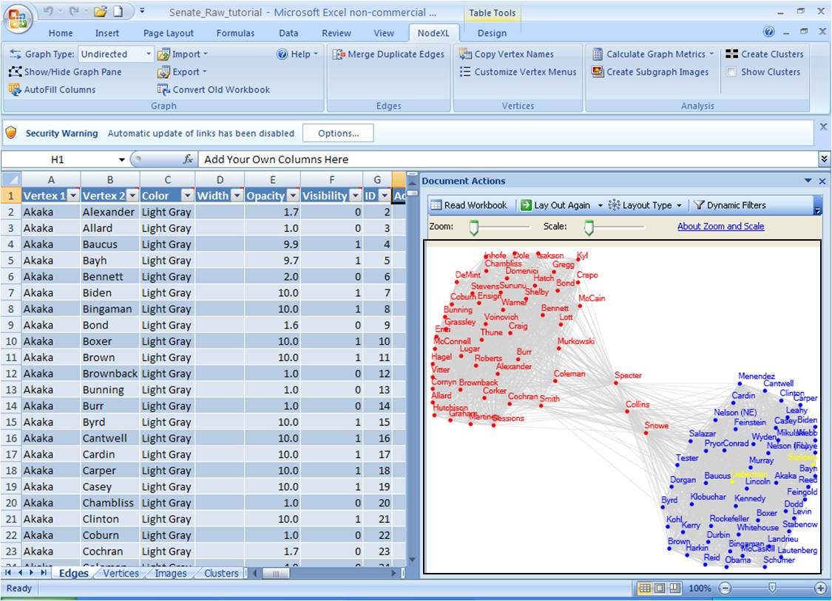

NodeXL allows users to analyze social media networks. This example shows U.S. Senate voting relationships and clusters for 2007. Edges between Senator vertices have a strength related to the percent of similar votes. The filters have been set to show only edges with at least 65% similar voting records. The Red Republican and blue Democratic Senators form distinct groups (including two yellow Independents), with three Republican Senators often voting more similarly to Democrats.

NodeXL is free to download at www.codeplex.com/nodexl and the book is available for students, researchers, and business professionals:
 | Hansen, M., Shneiderman, B, and Smith, M. A., Analyzing Social Media Networks with NodeXL: Insights from a Connected World, Morgan Kaufmann Publishers, San Francisco (2010).

